Lab 8

Exercise 1.1
Address 1: 0xB0f17Fd183A47114aB955F4C3a6fF4e49cE6A68f
Address 2: 0x67a2210AaB20912ea072F61a22d7f6C6B995B4cA

Exercise 1.2
The transaction with the hash 0x4aafcd1e3fcc175024e27f40abe0dfd62a9256f8e8181c8426c674b45b499624 was successfully executed on 22nd September 2021 and was include in the block of 11145250. It was done by this wallet address 0xc6Fd786bB7416ece05e6691eE4967ad062393842.
This transaction was carried out by PancakeSwap Router v2 which is a popular decentralised exchange on the BNB Smart Chain. The purpose was to convert Mattie token to Wrapped BNB (WBNB). The user had swapped 1,181,668.513145 Mattie to the PancakeSwape: Mattie 2 liquidity pool then the pooll returned for 0.164338052957493228 ($98.95) WBNB to the user wallet.

Exercise 2.1
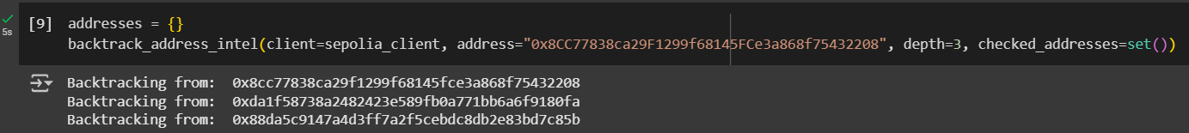
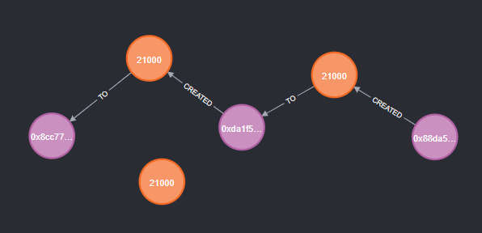
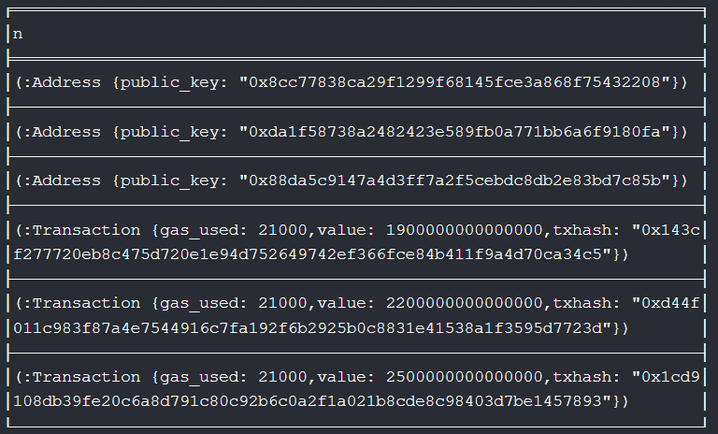

Exercise 3.1

The anonymity set of the pool at deposit D5 is:
Deposits it had were D1, D2, D3, and D4 which is 4
Withdrawals it had were W1, and W2 which is 3
Therefore, the anonymity set is 4 deposits – 2 withdrawals = 2

The anonymity set of the pool at deposit D6 is:
Deposits it had were D1, D2, D3, D4, and D5 which is 5
Withdrawals it had were W1, W2, W4, and W5 which is 4
Therefore, the anonymity set is 5 deposits – 4 withdrawals = 1
There is no additional anonymity added to W6 because only one deposit remains in the mixer contract, and it has not been withdrawn. This could mean that an outside observer has the ability to be completely sure that the deposit corresponds to W6. The anonymity set of 1 mean that there is no anonymity and that there are no other deposits it could have come from.

